# CS 255 System Design Document Template

## UML Diagrams

### UML Use Case Diagram

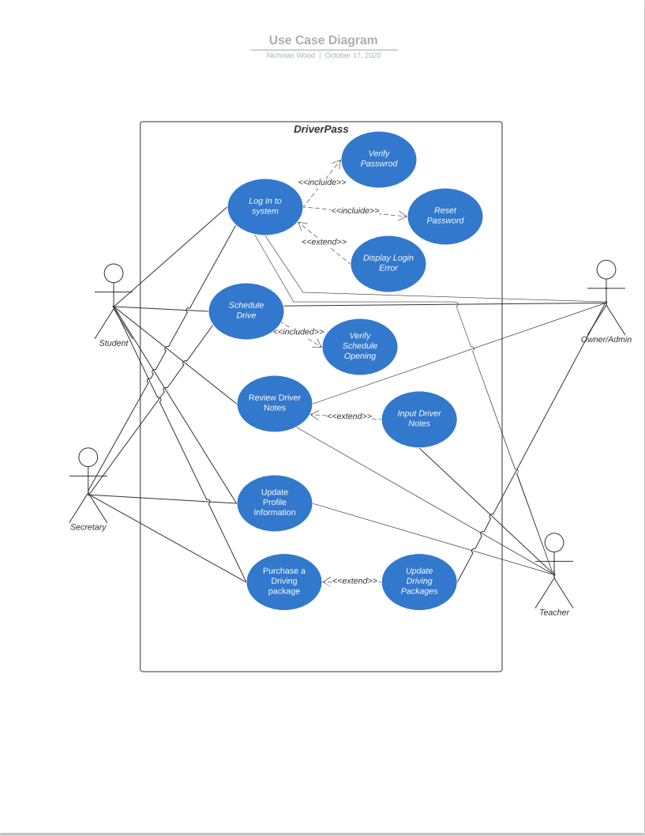

### UML Activity Diagrams

### UML Sequence Diagram

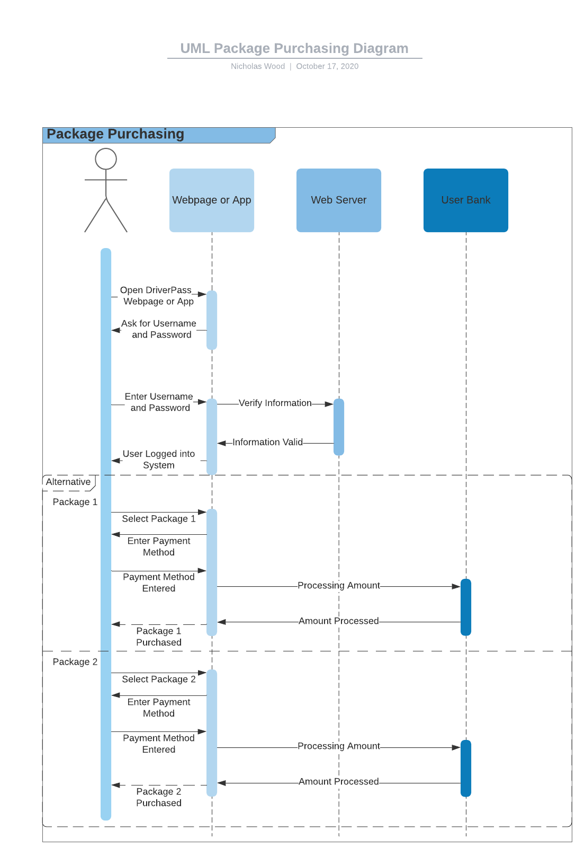

### UML Class Diagram

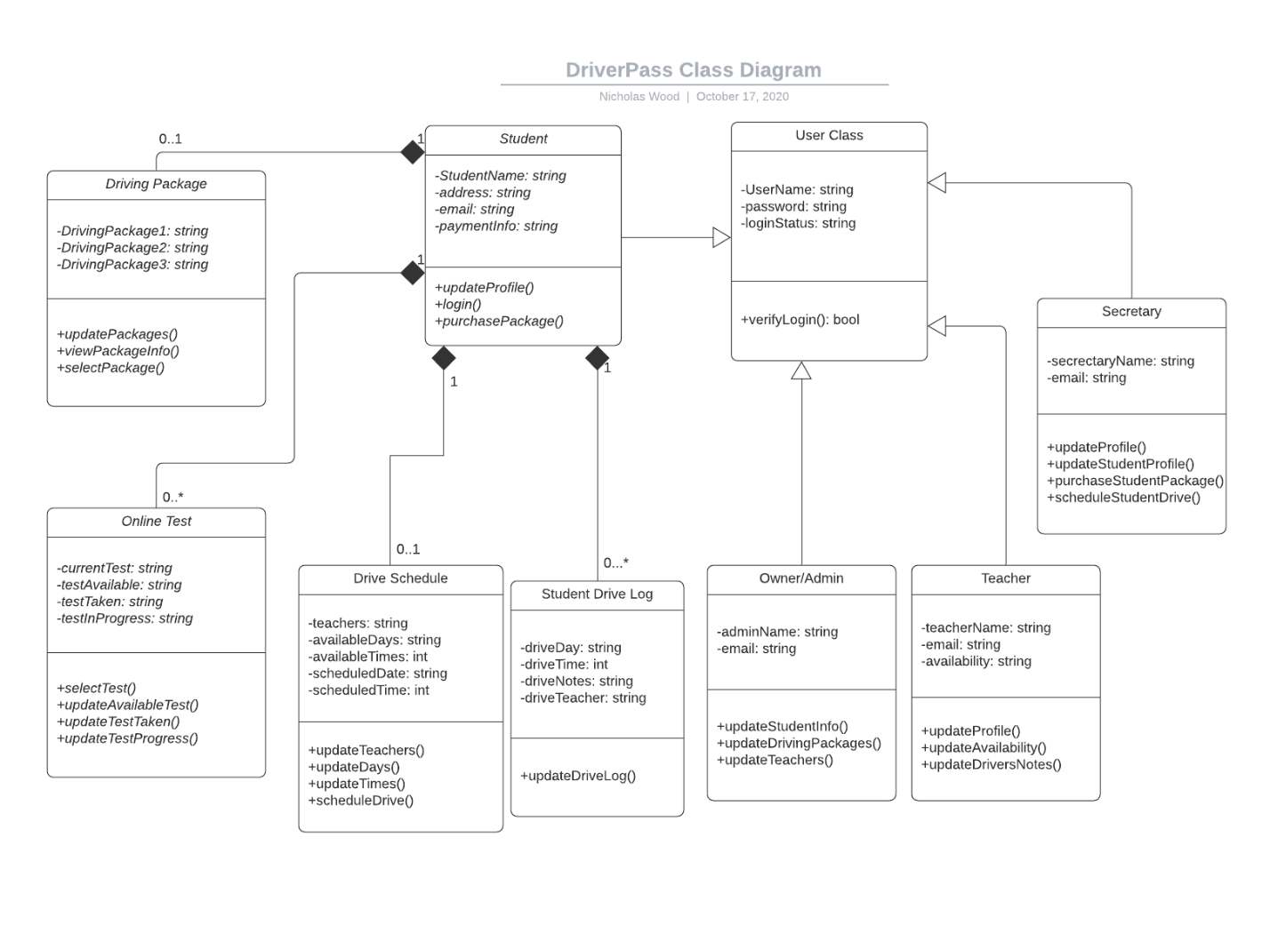

## Technical Requirements

* Hardware
  + Touchscreen Capabilities
  + Mouse Selection Capabilities
  + System will be accessed through the web and phone application
* Software
  + Operating System must be up to date
  + Software to read user input for user information
  + Security with server must be up to date
  + System updated with new information from DMV
* Geographical Information
  + Accessible anywhere access to internet is possible